CZ Scorpion 3+ Micro in 9mm: Full Review

The new CZ Scorpion 3+ Micro 9mm pistol is loaded with upgrades. Here's a full review.

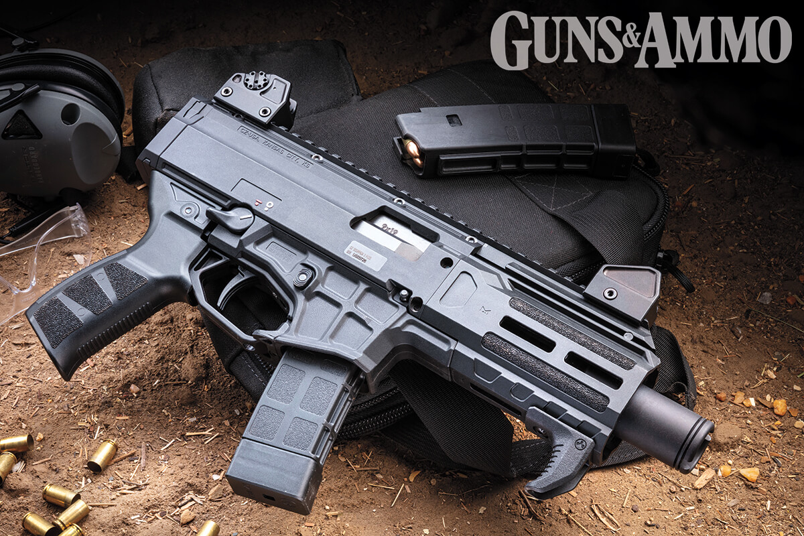 SEE PHOTO GALLERY

(Photo by Mark Fingar)
March 06, 2023By Jack Oller
Credit where credit is due, the MP5 is the most recognizable sub gun known today. However, the CZ Scorpion has given it a run for its money! The semiautomatic HK SP5 and SP5K sells between $3,000 and $5,000 — when you can find one available. Less collectible clones go for around $1,800. The CZ Scorpion EVO 3 S1 has traded hands for less than $1,200, and the aftermarket stepped up to support CZ’s popular model with enhanced parts, magazines, and muzzle devices.
Designed in 1959, the original Czech-manufactured Škorpion vz. 61 was produced between 1963 and 1979. It was chambered for 7.65x17mm Browning (.32 ACP) to meet the Czech Army’s need for an automatic, compact and light sub machinegun. But it became a popular export item as well. By the late 1990s, it was a frequent star in the movies, usually used by baddies. Its first appearance in an American film was “Freejack” (1992) starring Emilio Estevez.
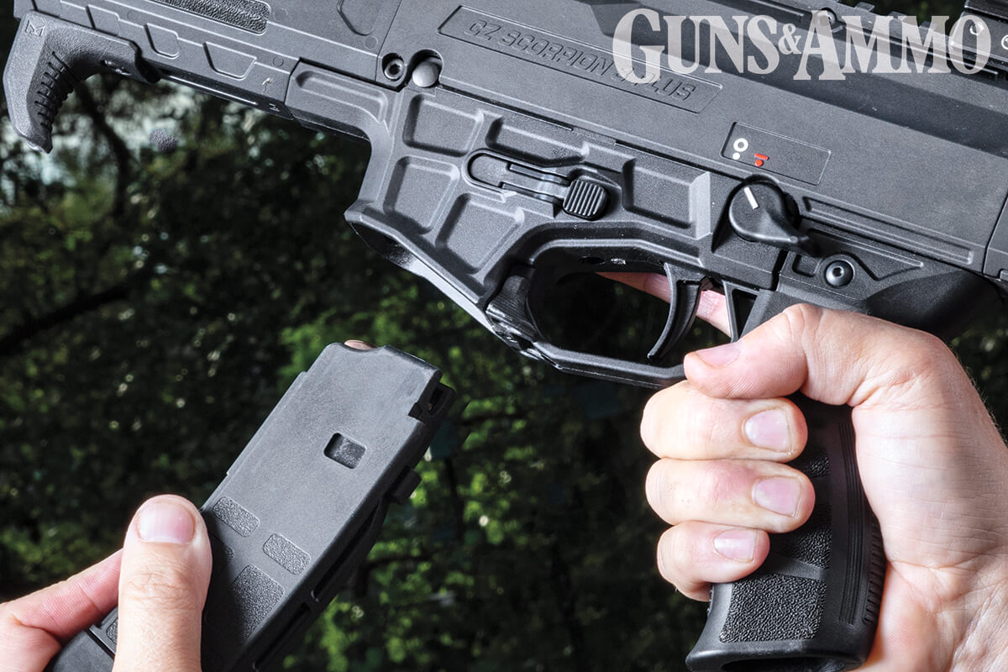
The AR-style magazine release is a notable improvement to the Scorpion design. The standard mags offer a 20-round capacity. (Photo by Mark Fingar)
The Scorpion name currently refers to the EVO design in 9mm, which was introduced to the American market in 2013. With nearly 10 years of customer feedback, CZ-USA unveiled the new-and-improved Scorpion 3+ Micro. CZ has packed a lot into this new design.

The Upgrades
There’s a lot to point out with the new 3+ Micro. First, it was great to see that the 3+ magazines are backward-compatible with previous Scorpion EVO models; and the 3+ Micro ships with two double-stack, 20-round mags. On the flip side, EVO 3 magazines will not work in the 3+ Micro. The reason is that the new magazines function with an ambidextrous AR-15-style magazine release. The new mag release is a marked improvement versus the previous design, which was motivated by the fact that the American market likes its controls in the style of the AR pattern. Hence, no additional training is necessary to become comfortable with the controls on the 3+ Micro.
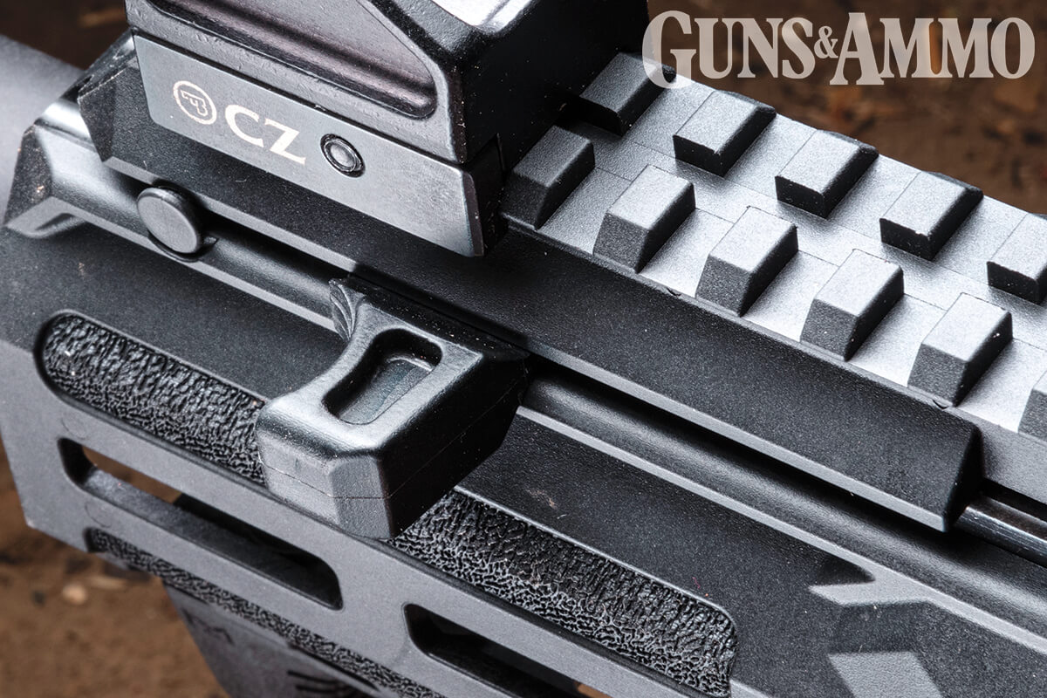 SEE PHOTO GALLERY
The stubby ambidextrous charging handle is non-reciprocating and unobtrusive. Working it is quite satisfying. (Photo by Mark Fingar)
The magazine well has also been improved. It was narrowed slightly and shaped for a better grip on the hand guard, and it sports an improved flare to quickly seat mags.
Continuing the ambi theme, the 3+ Micro has a bi-lateral bolt catch/release, which now sits behind the mag well and in front of the trigger guard. (This location is where the mag release was situated on the previous EVO 3 S1.) It’s easy to engage when inserting a new mag, and it’s a lot faster and minimizes superfluous movements when compared to using the charging handle. The ambi charging handle is still a nice feature, though. Like the previous Scorpion models, this one is non-reciprocating and very satisfying to slap the bolt home.
While the AR-style mag release is going to be one of the most praised features of the 3+ Micro, it’s hard to understate how much better the new grip is compared to the EVO 3 S1. Instead of a smooth and aggressively rear-angled grip, the new 3+ Micro grip is closer to an AR-15’s. It exhibits excellent texturing, and there’s a palm swell that fill the hand. It complements the new polymer hand guard, too. Together, the pistol grip and fore end provide superior handling versus the EVO 3 S1 pistol.

Photo Gallery



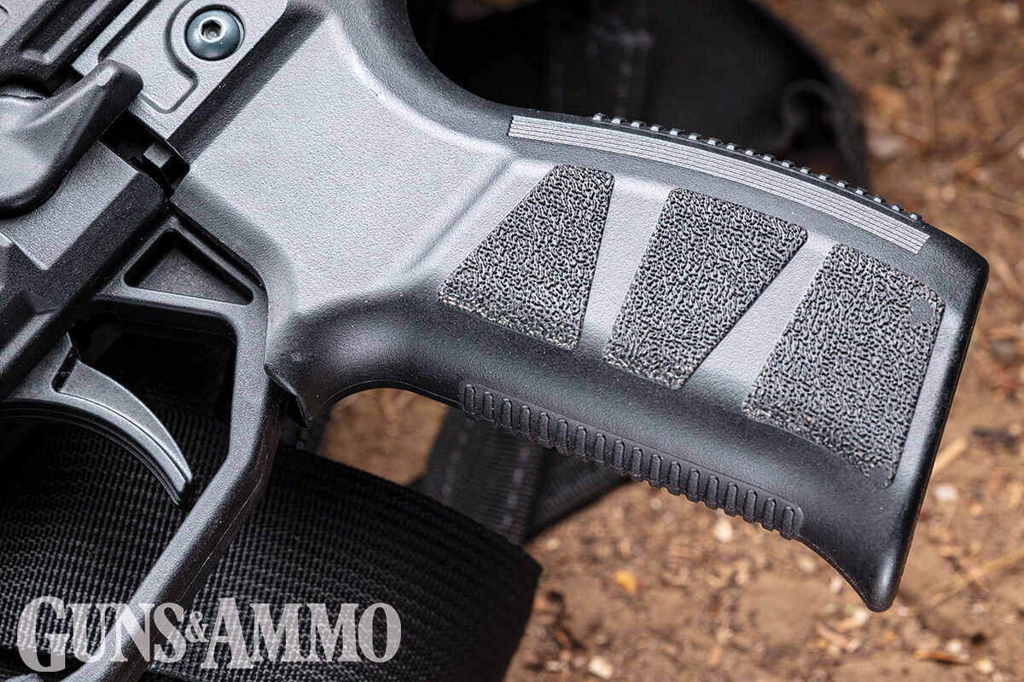 SEE PHOTO GALLERY
The AR-pattern grip offers a familiar feel to the shooter, and the combination of textures support positive control and handling. (Photo by Mark Fingar)
Concerned about a polymer hand guard on a firearm? It’s really a non-issue on the Scorpion 3+. It contributes to the platforms lighter weight, and it features M-Lok which is another improvement when compared to the Picatini rail on the EVO 3 S1. During Guns & Ammo’s testing, it proved more than durable while venting heat from hot barrel.
Like the grip and hand guard, the frame is also made of a polymer composite. The use of modern polymers throughout the 3+ Micro means that this pistol only weighs 4.7 pounds (unloaded). To round out its profile, it measured just shy of 15 inches (without an arm brace), and it uses an ambi thumb safety selector that is reminiscent of the MP5.

At the Range
The 3+ Micro is certainly an improvement, but there are some things you have to know. For example, when shooting these pistols without an arm brace, don’t expect an exceptional sub-gun experience. It’s just not the same. The 3+ Micro does not include a brace, which means that you’ll have to look at SB Tactical (sbtactical.com) or Gear Head Works (gearheadworks.com). Without a brace, precise accuracy beyond 15 yards can be challenging, but don’t rule out the 3+ Micro as an effective defensive tool. Fortunately, the 3+ Micro uses the same arm brace mounting interface as the EVO 3 S1, so there are several options on the market.
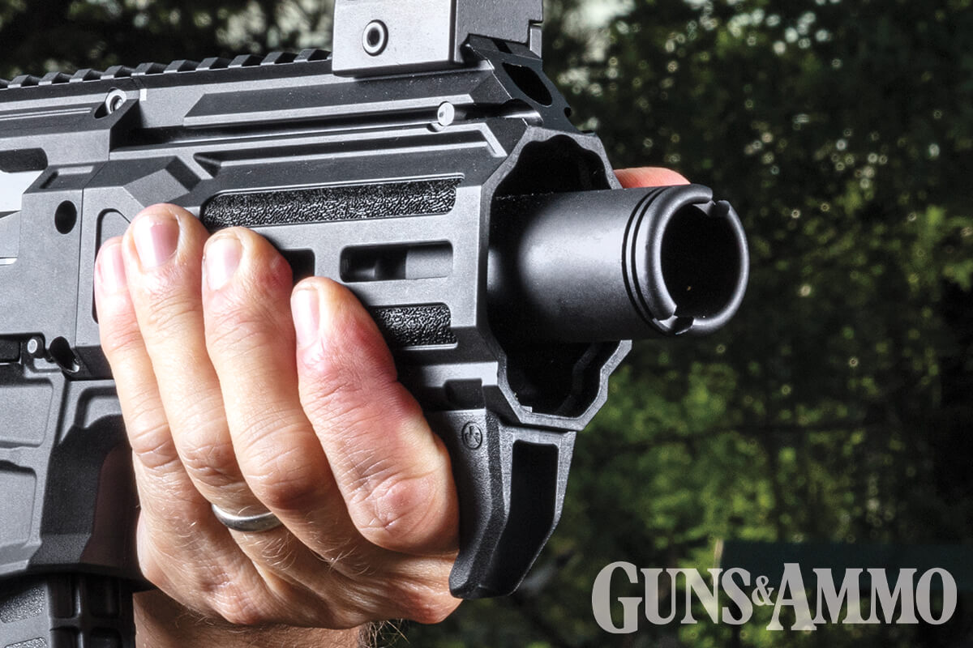 SEE PHOTO GALLERY
The polymer handguard has great ergonomics and textured touchpoints. Plus, M-Lok slots are ready to accept accessories. (Photo by Mark Fingar)
With a brace installed, the 3+ Micro is a lot of fun to shoot and impressively accurate. Six-inch steel plates at 100 yards were easy to hit, and it regularly held 1-inch groups at 50 yards. Even a folding brace covering the ejection port, brass still clears the brace, so don’t worry about ejected brass coming back into the action.
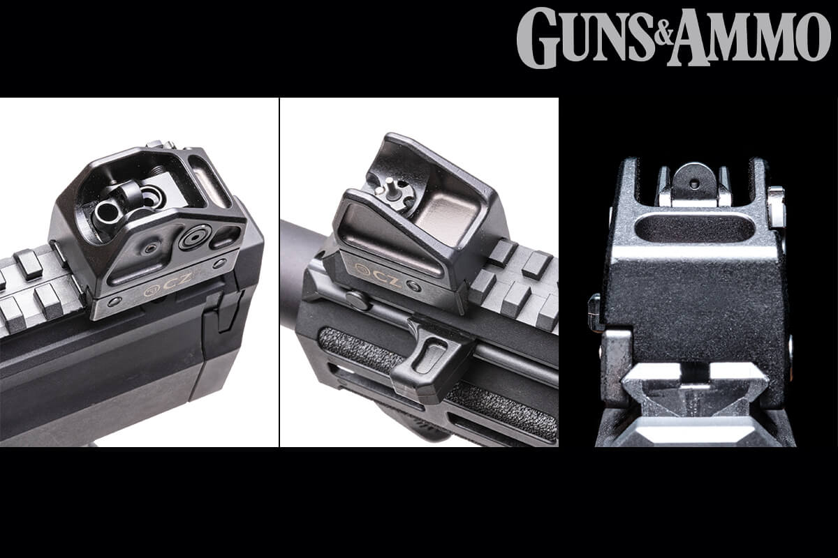 SEE PHOTO GALLERY
The continuous top rail comes with adjustable front and rear sight assemblies out of the box, including a rear with multiple flip-up apertures. The top rail provides generous space for a reflex optic. There’s even room available for a magnifier, laser, light or switch. (Photo by Mark Fingar)
The iron sights are a nice added value, but the Scorpion 3+ Micro is ideally configured with a red-dot sight. Still, the aluminium sights do offer four rotating rear apertures. CZ increased the height from previous models to better co-witness with red dots. However, they did not co-witness or raise the co-witness height to the lower third with many popular sights. If compatibility is important to you, be careful when selecting a red dot if want it to co-witness. Otherwise, the metallic sights are easy to use. They can function at extended distances when employing the appropriate adjustable aperture and tall, durable sides will protect the sights.
CZ Scorpions are known for reliability and performance. The 3+ Micro certainly maintains that standard. There were zero malfunctions during testing, even when loading one round from multiple loads into one magazine to throw it off. The Scorpion eats through everything.
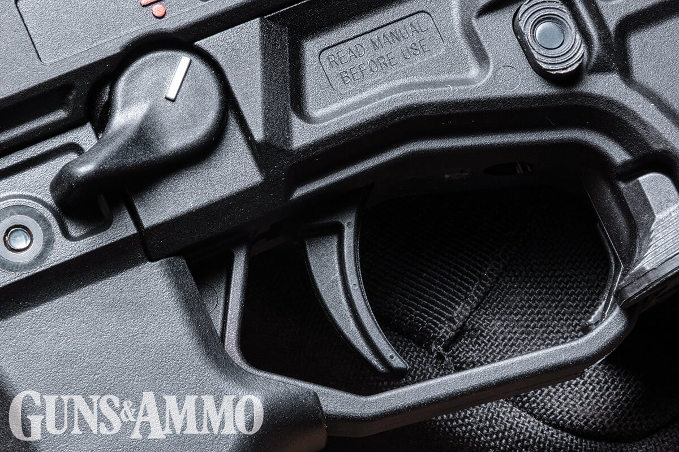 SEE PHOTO GALLERY
The trigger works fine, but the pull weight and feel is nothing like a premium AR trigger. Several aftermarket options are available. (Photo by Mark Fingar)
Compared to many AR triggers, the Scorpions have always had “meh” triggers out of the box. The 3+ Micro is no different. It will have more take-up and a longer reset than an AR’s, but it’s not really that bad once you get used to it. There are plenty of aftermarket options available though, for around $250. Its compact size and lightweight still makes the Scorpion fast to transition between multiple targets.
The biggest standout may be the new flash can. It did a great job reducing the blast from the short 9mm barrel. What’s especially appealing about the flash can is how easy it is to swap for a suppressor. The can sits several inches inside the hand guard, and is only a few inches shorter in overall length than many 9mm suppressors. Adding a suppressor won’t increase the overall length of the 3+ Micro terribly, and its blowback design is ideal for shooting suppressed cartridges.
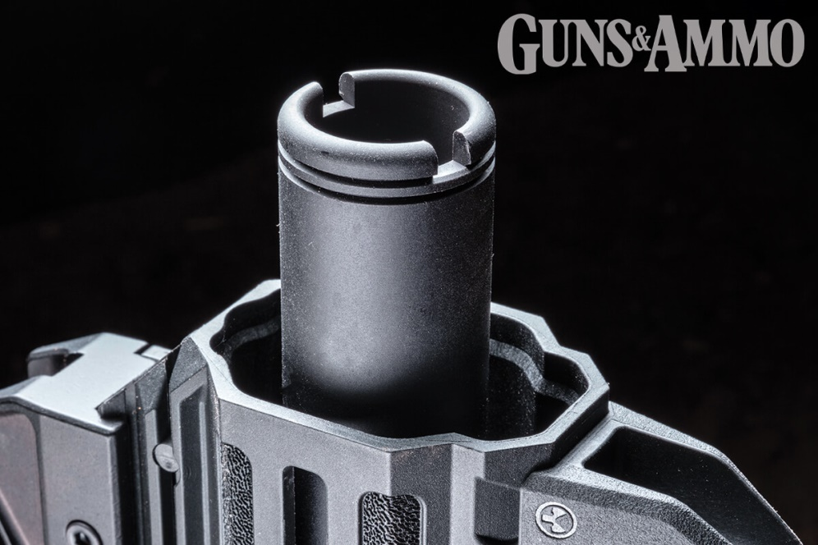
CZ’s flash can looks great in lieu of a suppressor, and it does a great job of reducing muzzle blast from inside the hand guard. (Photo by Mark Fingar)
Velocities were in line with what you would expect from a 4.3-inch, cold-hammer-forged barrel. Nothing broke 1,200 feet per second (fps), but CZ-USA will offer a 7.8-inch-barreled 3+ for more velocity. Still, the 3+ Micro is more than adequate for effective self-defence.
For fans of the Scorpion EVO 3 S1, the 3+.Micro is a welcome addition to the line-up. With a tried-and-true platform, the upgrades CZ made puts the Scorpion on par with the standards of the day. Be advised: If you find one in a gun store, it’s probably going home with you.

CZ Scorpion 3+ Micro
- Type: Blowback operated, semiautomatic
- Cartridge: 9mm
- Capacity: 20+1 rds.
- Barrel: 4.2 in.
- Overall Length: 14.63 in.
- Weight: 4 lb., 13 oz.
- Sights: CZ adjustable, aluminium
- Muzzle Device: CZ flash Can
- MSRP: $1300
- Importer: CZ-USA; cz-usa.com
